GOVERNMENT COLLEGE OF ENGINEERING [IRTT]

**ERODE: 638 316**



Electronics and Communication Engineering

**NAAN MUDHALVAN DIGITAL MARKETING ASSIGNMENT**

NM ID: F0720DE6E6C081799D64F126DAF8C430 NAME: GOKUL M

BRAND NAME: INCENSE SPOT

CATEGORY: PERFUME MANUFACTURER

1. Create a blog or website using Blogspot and WordPress. Customize the theme design and post new article with 500 words.

Screenshot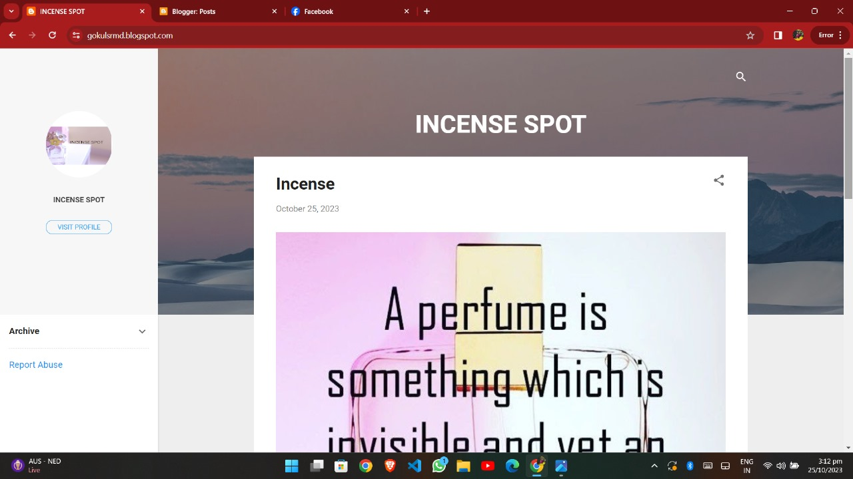

2.Create a New Facebook Business Page and post one social media poster for your brand.

Link: https://www.facebook.com/profile.php?id=61552481864416&mibextid=ZbWKwL

Screenshots:

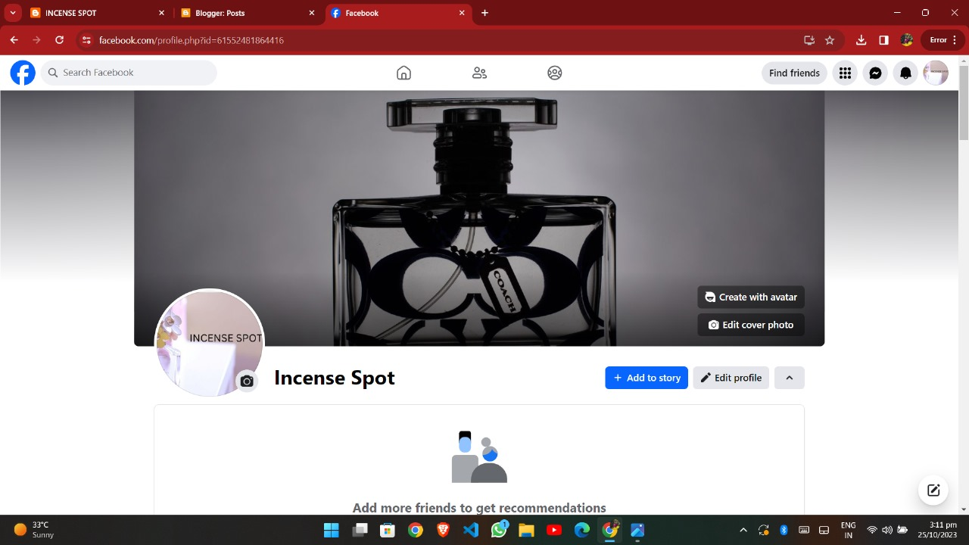

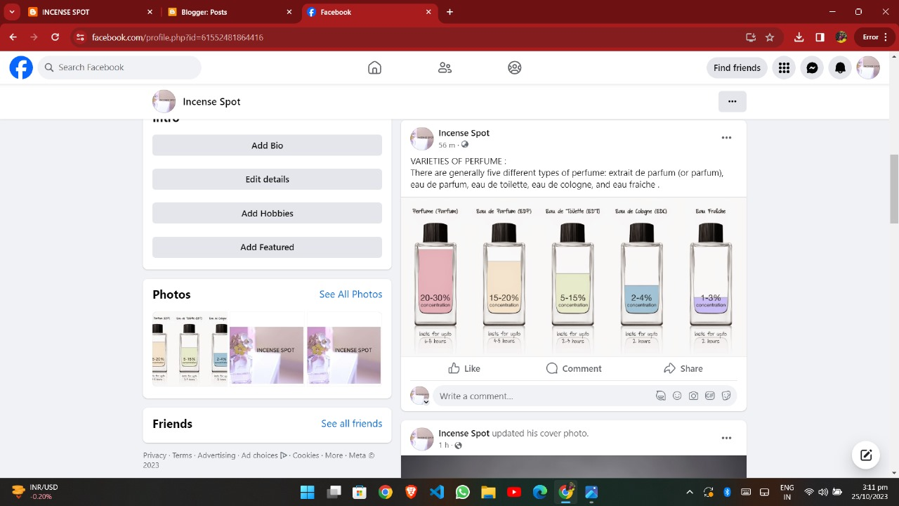

1. Create and design a social media advertisement poster using canva.

Link: Infographics Page Design using canva

https://www.canva.com/design/DAFyQaB7kKw/xHDX7ayfQoLaSlrJpoVCRQ/view?utm_content=DAFyQaB7kKw&utm_campaign=designshare&utm_medium=link&utm_source=editor

Screenshots:



3.Create email newsletter design using MailChimp or canva tool.

Link: Email newsletter design using canva

Screenshots:

https://www.canva.com/design/DAFyQT7TtqU/FdG0EEfGGvuETlRjOGWgTg/view?utm_content=DAFyQT7TtqU&utm_campaign=designshare&utm_medium=link&utm_source=editor